

Department of Science and Mathematics

BIOG-140.600 Cell & Molecular Biol Eng I

Gel Electrophoresis Data table

Experiment 7

Student Name: Sandra Raj

Student ID: 377004126

Semester: Spring 2025

Analysis of DNA Fragmentation Using Gel Electrophoresis

**Instructions:** Examine the provided gel electrophoresis image and answer the following questions.

**Data Table 1: Band Observation (2pts)**

|  |  |  |  |
| --- | --- | --- | --- |
| **Lane Number** | **Sample ID** | **Number of Bands** | **Approximate Size of Bands (bp)** |
| 1 | Ladder | 11 | 1200, 100, 900 |
| 2 | Sample A | 1 | 1000 |
| 3 | Sample B | 2 | 800, 200 |
| 4 | Sample C | 3 | 600, 300, 100 |

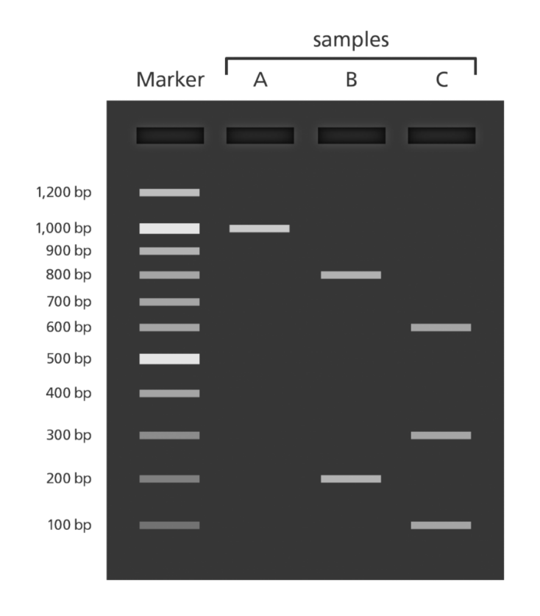

**Instructions:** Insert a picture of each component in the "Image" column and write its function in the "Function" column.

**Data Table 2: Gel Electrophoresis Apparatus and Functions (5 pts)**

|  |  |  |
| --- | --- | --- |
| Component | Image (Insert your image) | Function (Describe its role in gel electrophoresis) |
| Electrodes (Anode & Cathode) |  | Creates an electric field that drives negatively charged DNA fragments toward the positive anode. |
| Gel Tray |  | Holds the agarose gel in place during electrophoresis. |
| Agarose Gel |  | A porous matrix that separates DNA fragments based on size as they migrate through it. |
| Molecular Pipette (Micropipette) |  | Accurately measures and loads small volumes of DNA samples into gel wells. |
| Gel Comb |  | Creates wells in the gel for loading DNA samples. |
| Buffer Solution |  | Maintains pH and conducts electricity to allow DNA migration. |
| DNA Ladder (Marker) |  | A measurement reference with known fragment sizes to estimate the size of DNA samples. |
| Power Supply |  | Provides voltage to create the electric field necessary for DNA movement. |
| Loading Dye |  | Adds color to DNA samples for visibility and increases density for proper loading into wells. |
| UV Light or Blue Light Transilluminator |  | Visualizes DNA bands after staining, typically using ethidium bromide or other fluorescent dyes. |

**Instructions:** Answer the following questions based on your understanding of gel electrophoresis.

**Data Table 3: Conceptual Questions (3 pts)**

|  |  |
| --- | --- |
| Question | Your Answer |
| What is the purpose of gel electrophoresis in DNA analysis? | Gel electrophoresis is used to separate and analyze DNA fragments based on its size. This analysis includes visualizing DNA samples and comparing genetic material. |
| How can gel electrophoresis be used in forensic science or medical diagnostics? | It is used to identify suspects by comparing DNA samples from crime scenes in forensic science. In medical diagnostics, it is used to detect genetic mutations, diagnose hereditary diseases and analyze DNA for medical research. |
| Why do smaller DNA fragments migrate faster through the gel matrix, and what factors can affect the accuracy of fragment size estimation in gel electrophoresis? | Smaller DNA fragments migrate faster because they encounter less resistance while moving through the gel pores while large fragments experience more resistance. Factors affecting accuracy of fragment size include gel concentration, voltage applied, buffer composition, and potential sample contamination, quality of DNA ladder, etc. |